Test Project Module 4
(Advertising and display design)
WSC2013_TP40_M4_actual_EN
Submitted by: Group 4

Susan de Guzman AE
Prenesh Naidoo ZA
Lee Troxell US
Ramón Elías López CO
Teera Piyakunakorn TH
Farid Zaryab IR
Mosaab Al-Awadhi KW

- Contents

This Test Project proposal consists of the following documentation/files:
Este proyecto está basado en la siguiente documentacion/archivos:

- WSC2013_TP40_MOD4_Actual_EN.doc (project brief)
- WSC2013_TP40_MOD4_01_EN.zip (folder of images for the task 1) (refer to Appendix 1.3)
- WSC2013_TP40_MOD4_02_EN.zip (folder of logos and colour palette for task 1 & 2)
(refer to Appendix 1.4)
- WSC2013_TP40_MOD4_03_EN.txt (required copy for task 1)
- WSC2013_TP40_MOD4_04_EN.zip (fonts)

- Introduction

We are Sasol
Nosotros somos Sasol (Sasol es el nombre de la empresa)
Sasol is an integrated energy and chemical company that leverages the talent and expertise of more than 34,000 people working in 38 countries. We develop and commercialise technologies, and build and operate world-scale facilities to produce a range of product streams, including liquid fuels, chemicals and electricity. Today Sasol has grown to become South Africa’s leading fuel provider and an international player in the energy and chemical sectors.
Sasol es una compania que integra química y energia que aprovecha el talento y la experticia de mas de 34,000 personas que trabajan en 38 países. Desarrolla y comercializa tecnologia, trabaja y opera a escala mundial para producir un flujo de productos, incluyendo combustíbles líquidos, químicos y electricidad. Hoy, Seasol crece en torno a ser líder del mercado Sur Africano, y un gigante internacional de energia y el sector químico.

The South African Sasol Solar Challenge
El desafio Sur-Africano “Sasol Solar Challenge”
During September 2014, international and local teams will compete in the Sasol Solar Challenge, an epic two-week country wide endurance challenge involving engineered solar powered vehicles. Teams have designed and built their own innovative vehicles, which will be put to the test as they travel 5400 km across some of the most demanding terrain South Africa has to offer.
Durante el mes de septiembre de 2014, equipos locales e internacionales van a competir en “Sasol Solar Challenge”. Es una competicion epica de dos semanas, en campo abierto. Se trata de un desafio donde participan vehiculos movidos con energia solar.
Los equipos disenaran y construiran sus vehiculos innovadores, cada uno va a ser puesto a prueba en un viaje de 5400 Km, que atraviesa algunos de los terrenos mas exigentes que Àfrica del Sur tiene.
Teams from around the globe will descend on South Africa to participate in the Sasol Solar Challenge, the South African leg of the international solar car challenge. Held every two years, this eco-efficiency challenge allows teams from around the world to congregate to demonstrate the sophistication and performance of solar powered vehicles bringing through leading technology.
Equipos del mundo entero llegan a Africa para participar de Sasol Solar Challenge, una version sudafricana de competicion internacional de carros solares. LLevada a cabo cada dos anos, esta competicion ecoeficiente permite que equipos del mundo entero se congreguen para presentar un sofisticado show de tecnologia de punta de vehiculos movidos con energia solar.
Ranked as one of the top global events of its kind, the Sasol Solar Challenge is an exciting competition aimed at educating people in the areas of science, innovation, teamwork and business principles. The challenge is a collaborative approach between scholars, students, private individuals and various industry and government partners that will see competitors come together to design and build their own engineering systems, and ultimately drive a solar powered vehicle cross country.
Clasificado como uno de los mayores eventos mundiales en esta área, “Sasol Solar Challenge” es una competicion excitante destinada a ensenar a las personas, princípios de: ciencias, inovacion, trabajo en equipo e emprendimiento. Una competicion donde la colaboracion entre profesores, estudiantes, emprendedores, muchas industrias y companias estatales que observan los pormenores del trabajo en conjunto para desarrollar sus propios sistemas de ingieneria y, fundamentalmente, para manejar un poderoso vehiculo movido con energia solar.
Solar power is flexible and can offer energy solutions across different applications to utilise in a carbon-constrained world. Developing alternative energy technologies, such as solar will contribute to the worlds transition to a low carbon economy.
La energia solar es flexíble y puede ofrecer soluciones alternativas para diferentes aplicaciones en un mundo dominado por el carbono. Desarrollando tecnologias alternativas para energia, tal como la solar, contribuyendo para la transicion a un mundo con menos polucion.
The 5400km challenge will see the solar cars depart on a two week journey around the country through different terrains in cars that have been conceptualised and designed entirely by the teams participating.
El desafio de 5400 Km consiste en un viaje de dos semanas alrededor del País, sobre terrenos diferentes, en carros que tienen que ser disenados y construidos completamente por los equipos participantes.
Sasol Solar Challenge key objectives of the competition is to encourage young minds to become involved in innovation, engineering and the sciences.
El principal objetivo de “Sasol Solar Challenge” es encontrar mentes jovenes que desarrollen ideas - en innovacion, ingieneria y ciencias.

Project focus: This project is focused on the awareness of sustainable, innovative energy being the driving factor.
Objetivo del Projecto: Este projecto está enfocado en premiar la sustentabilidad, siendo la inovacion energética el factor mas importante.

Description: There are 2 tasks related to Advertising and Promotional Design.
Descricao: Debe realizar 2 tareas relacionadas con la Publicidad y el Merchandising

Target market: Typically directed at public interest for support and awareness of all ages.
Publico-Alvo: Dirigido a un público preocupado por la sustentabilidad, de todas las edades

- Description of project and tasks
Descripcion del proyecto y tareas

TASK 1 – The Sasol Solar Challenge Poster Design
TAREFA 1 – Desarrollar un poster para el “Sasol Solar Challange”

Subject: Every two years a design is conceptualized that encapsulates and visually represents the two-week challenge. The current design demonstrates the message of distance, location, cities and an abundance of energy and vibrancy.
Assunto: Cada dos anos es realizado un Grafismo nuevo que ilustra y representa el desafio de las dos semanas. El Grafismo del ano pasado transmitia un mensaje de distancia, localizacion, ciudades y abundancia de energia e intensidad.

This concept is at the core of all design elements throughout the campaign and should represent the following key words conceptually; dynamic, innovative technology, solar energy, endurance and challenge. As the event is sponsored by a global company, the design should still have a subtle corporate look while being engaging and compelling to the public, creating interest and support.
El concepto de este ano debe representar: dinamica, tecnologia inovadora, energia solar, resistencia y desafio. Como el evento es patrocinado por una empresa global, el diseno debe tener un aspecto corporativo, manteniendo una coherencia de compromiso con el publico, creando intereses y de apoyo.

Description: Let your creative genius side go wild and design a captivating A3 poster with maximum impact. The goal of the poster must be to have a fresh concept that emulates the Sasol Solar Challenge brand.
Descripcion: Libera tu genio creativo y desarrolla un poster atrayente en formato A3, con el máximo de impacto posible. El objetivo de el poster debera tener un concepto fresco que emule el pensamiento de Sasol Challenge .

- Refer to Appendix 1.1 for an example of the 2012 campaign.
Consulta el Appendix 1.1 un ejemplo de la campana de 2012.
- At least two images provided must be merged and placed on the poster.
Por lo menos dos de las imagenes entregadas deben ser incorporadas al poster
- Generate an A3 poster using images provided (WSC2013_TP40_MOD4_01_EN.zip)
Realice sobre A3 utilizando las imagenes entregadas (WSC2013_TP40_MOD4_01_EN.zip)
- Use the two supplied logos on poster (WSC2013_TP40_MOD4_02_EN.zip)
Usa los dos logos entregados para el poster (WSC2013_TP40_MOD4_02_EN.zip)
- Apply supplied copy (text) to poster (WSC2013_TP40_MOD4_03_EN.txt)
Aplica en el poster el texto entregado (WSC2013_TP40_MOD4_03_EN.txt)
- Save the final poster-working file in the layout application software format.
Guarde el archivo final del trabajo del poster en el formato y software apropiado

Technical specifications for poster
Especificaciones técnicas para el poster

Dimensions: 297 mm X 420 mm (final trimmed size) (tamano final cortado)
Bleed: 3 mm
Colour Mode: CMYK + spot (logo)
Stock: Coated paper
Screen ruling: 150 LPI
Image resolution : 300 PPI
ICC Colour profile : ISO coated v2 (ECI)

You must deliver
Debes entregar

• 1 final A3 Poster file saved as a native file.
1 poster final A3 guardado en formato nativo
• 1 final CMYK A3 poster file saved in PDF/x-1a:2001 with 300ppi images using the ICC profile indicated.
1 poster A3 / CMYK guardado en PDF/x-1:2001 con imagenes a 300 ppi, utilizando el perfil ICC indicado
• 1 final composite printout, trimmed and mounted on a board for presentation.
Una impresion de la composicion final, cortada y montada sobre soporte para la presentacion.

TASK 2
TAREA 2

Subject: T-shirt & Cap design – promotional material
Asunto: Diseno de camiseta y gorra – material promocional

Description :
Descripcion:

You are tasked with marketing material for the Sasol Solar Challenge brand. We want you to design a t-shirt and cap. The design must capture the essence of the event by using your creative artistic flair and adding a touch of brilliance in a clever and appealing design.
Usted debe desarrollar material promocional para “Sasol Solar Chalange”. Queremos que realices el diseno para una camiseta y una gorra. El diseno debe capturar la esencia del evento, debes utilizar todas tus capacidades artisticas para crear un diseno brillante, inteligente con un toque de genialidad.

The aim of this branding exercise is to create media excitement and create awareness which will position the Sasol Solar Challenge in a positive way.
El interes de este ejercicio es crear soportes interesantes y generar un medio para posicionar el evento, colocando a “Sasol Solar Challenge” en un rumbo positivo.

Refer to Appendix 1.2 for an example of the 2012 campaign.
Consulta un ejemplo Appendix 1.2 para ver un ejemplo de la campana de 2012.

Target market: General Public of all ages
Pùblico-Objetivo: Publico en general de todas las edades

Instructions
Instrucciones

With the description above, design a full colour t-shirt and cap for the Sasol Solar Challenge. Produce an interesting, expressive design. Your design must be witty and intelligent, sending a clear message leveraging media and supporting the solar initiatives.
Con la informacion disponible, disena una camiseta y una gorra coloridas (full color) para “Sasol Solar Challenge”. Desarrolle un diseno interesante y expresivo. Su diseno debe ser espirituoso e inteligente, enviando un mensaje claro y soportando la iniciativa solar.

- Create a t-shirt design (front and back) using the text slogan “commit to the challenge” and “2014”.
Crear un diseno para una Camiseta (frente y reverso) utilizando el slogan “commit to the challenge” and “2014”
- Create a cap design using the text slogan “commit to the challenge” and “2014”.
Crea un diseno para una gorra utilizando el slogam “commit to the challenge” and “2014”
- Create an accompanying “vector t-shirt and cap” template (back, front and side) that you must use to present the concept design on.
Realiza un diseno vectorial de la camiseta y la gorra (template) (atras, de frente y de lado) que debes usar para presentar los dos conceptos (Disenos)
- Save the artwork in A3, landscape, in the native application and pdf formats.
Salve el trabajo en A3, horizontal en la aplicacion nativa y el formato pdf
- The Sasol and Sasol Solar Challenge logos must be used in both designs
Los logos de “Sasol” y “Sasol Solar Challenge” tienen que ser usados en la camiseta y en la gorra
- The logos must not exceed 90 mm wide on the cap.
Los logos no pueden exceder de 90 mm de largo en la gorra .

Technical specifications
Especificaciones técnicas

Dimensions: A3 (final trimmed size) Tamano final cortado
Orientation : Landscape Horizontal
Image resolution : 250 PPI

You must deliver
Usted debe entregar

• You must illustrate or draw a t-shirt and cap to place your design on, in its native format for the t-shirts.
• Debes disenar una ilustracion de una camiseta y de una gorra , donde vas a aplicar/colocar tu diseno, el archivo debe ser entregado en formato nativo.
• Your design is required to have front and back views with at least one spot colour.
• Su diseno requerido debe tener frente y atras debe verse con un spot color
• 1 final A3 composite colour printout (fit to page) versions trimmed and mounted on a board.
• 1 impresion en A3 (fit to page), cortada y montada sobre un suporte.
• 1 final A3 printout with trim marks, registration marks, bleed and colour bar unmounted
• 1 impresion con marcas de corte, marcas de registo, sangria, barra de colores – sin montar
- Instructions to the competitor

Create a folder on your Desktop called YY_MOD4 (where YY represents the number of your workstation). This folder must include the following subfolders:
Cree una carpeta en su escritorio llamada YY_MOD4 (donde YY representa el número de su estacion de trabajo.

- Final_files: it should contain all the files you are supposed to deliver as required in the tasks (PDF, etc.).
- Archivos finales: debe contener todos los archivos que fueron pedidos en las tareas (PDF, etc.).

- Original_files: it should contain all the files used for the development of your project, properly organized (fonts, links, etc.).
- Original_files: debe contener los archivos que usaste en el desarrollo de los projectos. (fonts, links, etc.).

Any file saved out of its respective folder WILL NOT BE EVALUATED.
Ningun archivo por fuera de su respectiva carpeta NO SERA EVALUADO

Note: Nota:
- Examples provided are for reference only and should not be used.
- Los ejemplos entregados solo sirven como referencia, no pueden ser usados
- The Sasol colour palette corporate identity guidelines must be followed.
- La paleta de colores usada para la identidad corporativa de la empresa (codificacion cromatica) debe ser respetada
- The colour green must be omitted from all designs
- El color verde debe ser retirado de todos los disenos

Time limit for this test project:

- Equipment, machinery, installations and materials required
• No specific information

- Marking scheme

Subjective
10 marks

A.1 Ideas and originality (task 2) 1
A.2 Understanding target market (task 2) 0,5
A.4 Relevance of all aspects in the task (task 2) 0,5
B.1 Effective use of visual composition (including typography) (task 2) 3
B.6 Suitability of the colour choice (task 2) 1
B.7 Quality of the colours used (task 2) 1
B.8 Quality of image manipulation (task 1) 1
B.9 Quality of image colour correction (task 1) 1
B.10 Quality of image blending (task 1) 1

Objective 15 marks

C.1 Resolution of images (task 1) 1
C.2 Colour mode of images (task 1) 1
C.3 Logo dimensions (task 2) 1
C.10 All required elements are present (task 1 and task 2) 1
D.1 Trimmed printouts for presentation (task 1) 1
D.2 Mounted printouts on board for presentation (task 1 & task 2) 1
E.1 Bleed value applied (task 1) 2
E.4 Spot and CMYK colours used as required (task 2) 1
E.6 Printout supplied unmounted (trim marks, registration marks,
bleed and colour bar) (task 1 & task 2) 1
F.1 Source file/native files supplied (linked images, font, ICC profile) (task 1) 2
F.2 ICC profile embedded in the PDF (task 1 ) 1
F.4 All files saved in the right folders (task 1 and task 2) 2

Appendix 1.1

Appendix 1.2

Appendix 1.3
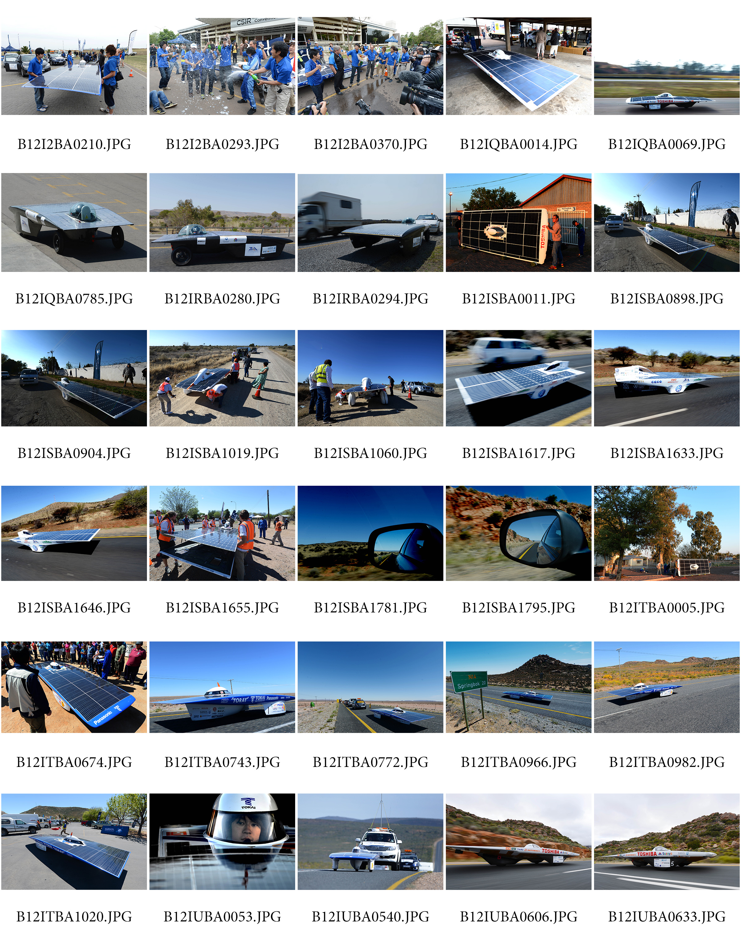


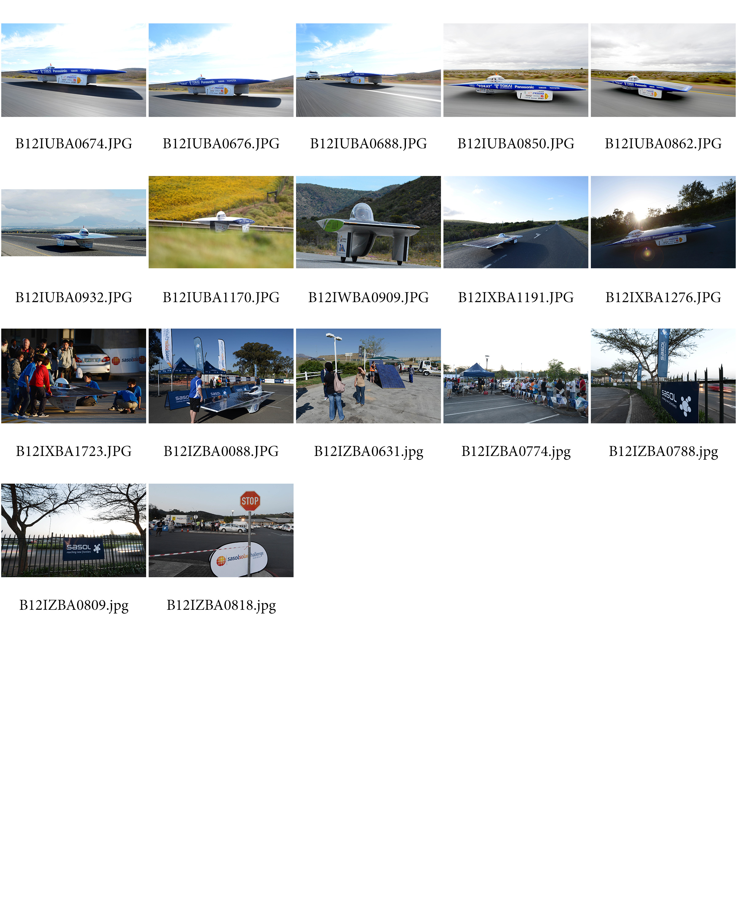

Appendix 1.4
